No Toy Bag? No Routine? No Problem! Language Is Free and Everywhere
Best practices in early intervention (EI) are known as family-centered, strengths-based and routine-focused to effectively coach parents as their child’s teacher and advocate. Embedding language into what the family is already doing from day-to-day is one of the most natural ways to consistently promote language development.
It is the EI provider’s role to help families uncover what they would say in their daily routines and activities with their child. One way to do this is to give them examples of common, language-rich phrases. However, we are ultimately empowering the family to pick and own what is must natural to them with confidence.
Here are some examples of day-to-day routines and common language we may suggest. An EI provider might go through the list with a family and then ask them which phrase is most natural for them and to use the language consistently.

- Wake up What would the family say?
  - “Hi (child’s name!)”

  - “Good Morning!”
  - “Do you want to get up/down?”
  - “ I want a hug/kiss.”
  - “Pull up the blinds. Pull! Pull! Pull!”
  - “Let’s change your diaper! Pee-yew!”
  - “Put your shirt on. Where’s your head?”

- Meal time
  - “Sit down in your chair.”

  - “Do you want a bite?”
  - Do you want the pink cup or the green cup?”
  - “More cookie.”
  - “Wash your hands. Wash! Wash! Wash!”
  - “Open the milk.”
  - “That was a big bite!”

- Play time

  - “Roll the ball.”
  - “Walk. Walk. Walk.”
  - “The cow says Moo!”
  - “The truck is big!”
  - “Shhhh! Night, night baby.”
  - “More blocks.”
  - “Wow that car is fast!”
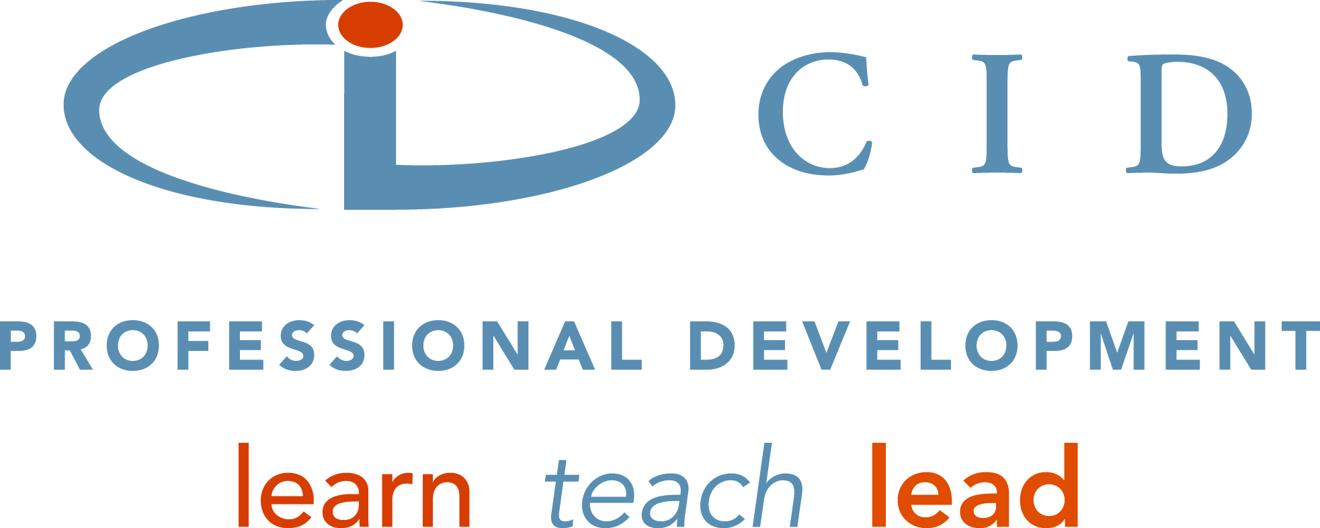
The possibilities for language are endless to use throughout the day. The most important piece is that families feel confident and natural with how they talk to their children. It doesn’t have to be the same language each time. It can differ, which will expand the child’s language even more!

