Tele-Audiology: Remote Newborn Auditory Brainstem Response (ABR) Testing

This program was developed for newborns born at Blue Mountain Hospital and surrounding communities that did not pass their newborn hearing screening. Infant diagnostic hearing evaluations require an audiologist with expertise in electrophysiological testing …..

Consultant Site: Utah Early Hearing Detection and Intervention
44 North Mario Capecchi Drive
Salt Lake City, UT 84113
(801) 584-8215

Schedule Evals:
Phone:
Email:

EHDI Key Contacts:
Audiologists:

Dept Technology Services

Vivosonic (manufacturer tech support) (877) 255-7685

Hospital Site: Blue Mountain Hospital
802 South 200 West
Blanding, UT 84511

Hospital Key Contacts:

Utah Telehealth Network:

Appropriate Patient and Type of Consult:
If baby is at high risk for LTFU, contact Utah EHDI to complete tele-ABR if newborn fails last screen before discharge. Have CMV testing completed before family leaves hospital.

Any newborn who has failed two hearing screenings (one inpatient and one outpatient) will require CMV testing and diagnostic ABR evaluation to rule-out hearing loss.

Referral and Scheduling Procedure:
Referral Process: The diagnostic evaluation should be scheduled before the family leaves the 2nd/outpatient screening. Patient information needed: Inpatient and Outpatient hearing screening results for both ears; Primary Care Physician; Confirm family contact information in order to provide reminder call before appointment.

Scheduling Process: BMH Staff will contact Shannon Wnek or Jenny Pedersen to schedule the diagnostic evaluation. If they are not available: 1) _______ 2) Email Shannon Wnek, Jenny Pedersen; 3) Call EHDI Program Main Line 801-584-8215

Telehealth Consult Procedures:

Pre-examination:
Education and Training:
- Mock tele-audiology consultation will be completed prior to seeing patients. Utah EHDI staff will travel to BMH for onsite training. Training to include:
  - Registration/Check in
    - Utah EHDI will not bill for services rendered
  - Consent Forms
  - Skin/Electrode prep
  - Electrode placement
  - Otoacoustic emissions (OAE) Probe and insert(s) placement
  - Connecting ABR (Vivosonic Integrity) to tele-health suite
    - Bomgar (takes over computer - keycode provided to Consultant to give to Hospital Site)
    - Utah Telehealth Network/Adobe Connect (video source to see patients): Utah EHDI will initiate the videoconference. CART #: ******
  - Troubleshooting

Preliminary Information and Instructions
- Patient Information
  - Baby Name, DOB
  - Parent Name, Phone number, 2nd point of contact
- Before Tele-ABR
  - Information needed for audiologist prior to evaluation:
    - Inpatient and Outpatient hearing screening results (ear-specific testing, OAE vs. AABR)
    - CMV testing results (or note if they are pending, parent refused, etc)
  - Explain to parents the diagnostic procedure
    - ESSENTIAL to Success!!! Baby needs to be sleep-deprived and hungry. Do not allow baby to sleep in the car on the way to appointment. Do not feed baby until already scrubbed and electrodes placed. The effectiveness of our testing will depend on how still they are (both physically and “quiet EEG”).
- Schedule diagnostic appointment as soon as baby fails 2nd hearing screening
  - Contact ________ to arrange diagnostic evaluation
- Conduct reminder call 24-48 hrs before diagnostic evaluation
  - Remind them to bring the baby sleep deprived and hungry
- Obtain Patient Informed Consent
  - BMH will obtain a signed Telehealth consent form from the parent/caregiver at the time of ABR appointment. An original copy of the consent form will be kept in the patient’s file at the hospital site and a copy will be emailed to ___________.

Exam Room preparation:

- Blue Mountain Hospital
  - Supplies
    - Vivosonic Integrity V500 G2 (ABR + DPOAE) with Two-Channel S/N IK0330 (BMH responsible for at least bi-annual calibration)
    - Earlink 3A/5A 4mm Newborn/Infant Eartips - 20/pkg (inserts)
    - Earlink 3A/5a 3.5mm newborn/Infant Eartips - 20/pkg (inserts)
    - Ambu Neuroline 720 Disposable Electrodes - 25/pkg
    - Yellow 3-6mm OAE Eartips - 100/pkg (Part: KR036)
    - Blue 3-8mm OAE Eartips - 100/pkg (Part: MF003)
    - PDI Electrode Prep Pad w/Pumice - 100/box
    - If needed, Audiology-specific supply company options:
- MSR West: www.msrwest.com/Utah; (800) 323-4371
- Audiology Systems: http://www.audiologysystems.com/; (855) 283-7978
  - Technical Needs
    - Utah Telehealth Network
    - Bomgar - provides Distant Site secure (encrypted) access to remote desktop (Originating Site). This allows Utah EHDI to access/control ABR equipment at Hospital
    - Internet Access (hardwired access required)
    - Videoconferencing equipment—UTN Connect (Adobe)

- Utah EHDI
  - Headphones with mic
  - Video camera
  - Two laptops - 1) Bomgar for ABR testing; 2) UTN Connect for Video
  - Two internet cables to hardwire laptops (Conf F phone cable + extra cable)

After Evaluation:

- BMH will have family complete tele-audiology survey before they leave.
- Utah EHDI will save and download ABR waveforms
- Utah EHDI will email waves to consulting audiologist
- Consulting audiologist will prepare ABR Report, mail to family and primary care provider (if known), and email to BMH.
- Utah EHDI will enter diagnostic results and recommendations into HiTrack.

Patient Examination
- Connection Procedure
  - Turn on laptop (Vivosonic) and Telehealth cart equipment
  - Connect to internet
  - Connect to Cisco Jabber or other agreed upon connection software
  - Connect with EHDI/Audiologist using Bomgar: support.dts.utah.gov
  - Supplies needed
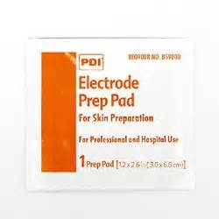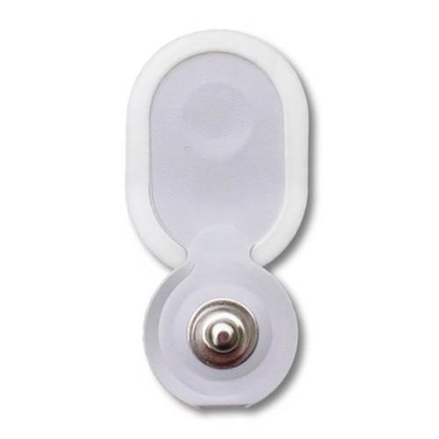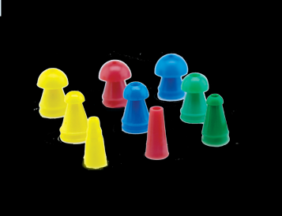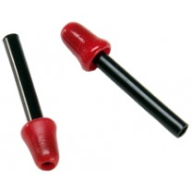
Skin Prep (1) Electrodes (4) OAE tips Inserts (2)

  - Prep Baby
    - Gently scrub baby’s forehead and mastoid
    - Place electrodes on high forehead, low forehead and both mastoids (**see images of baby below**)
      - When placing, do not push in the center of the electrode - the conducting gel will be pushed out
      - Gently push the outer edges of the electrode to seal the adhesive
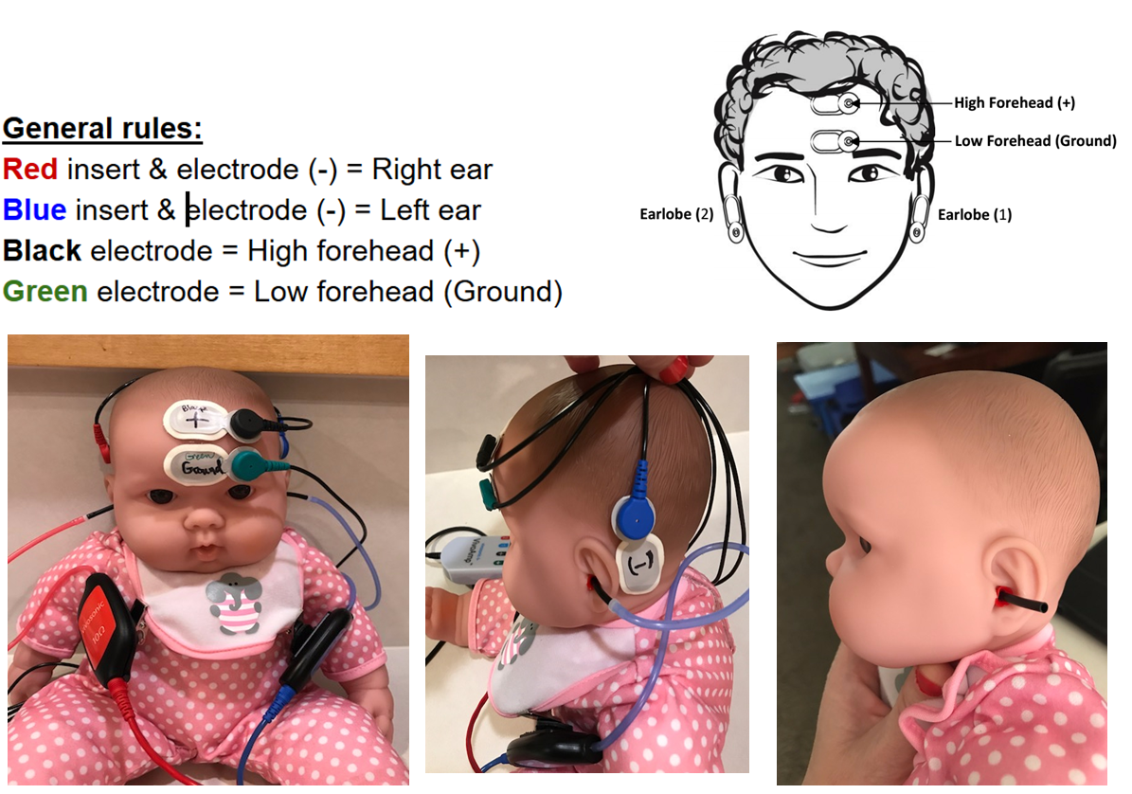
      - Forehead - do not allow electrodes to touch - this can cause interference
Connecting to Bomgar: Go to support.dts.utah.gov and select #228 - HSVS

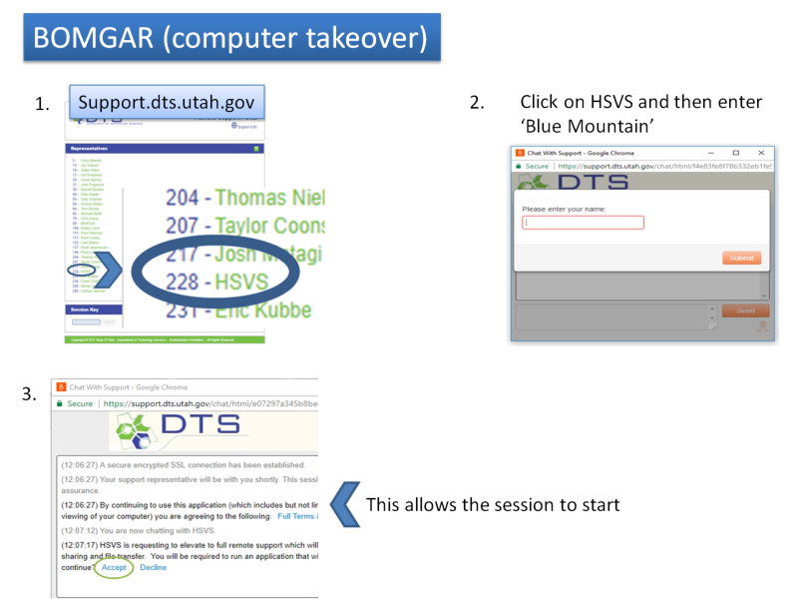

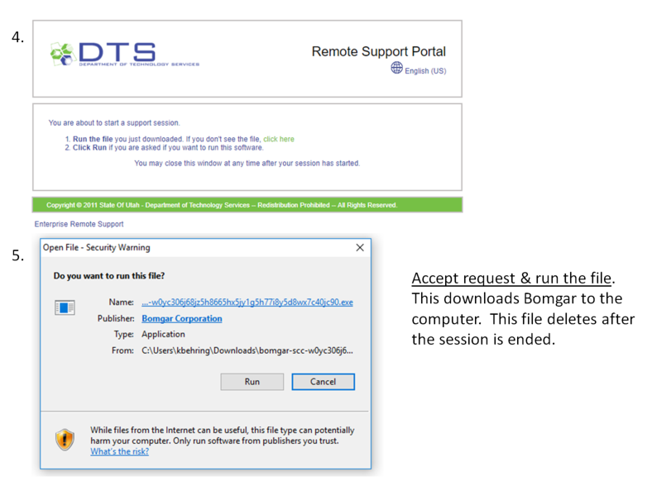

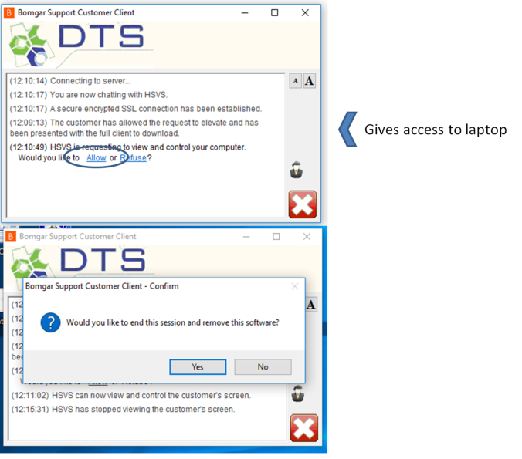

NOTE: You will have to press “Allow” twice: first to allow screen access and then to elevate privileges so the audiologist can control your computer.

