What I Would Like My Healthcare Provider to Know
Hi! My name is:
My birthday is:
I describe myself as:
My favorite color is:
My favorite activity is:
My favorite toy is:
My favorite food is:
Communication Type  Circle: | 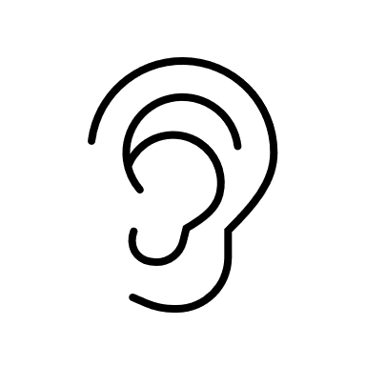  Listening and Spoken Language? |  | Writing? |  | Signing? |  | Other?
Please Consider: | Background Noise 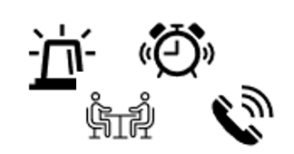 |  | My Cochlear Implant  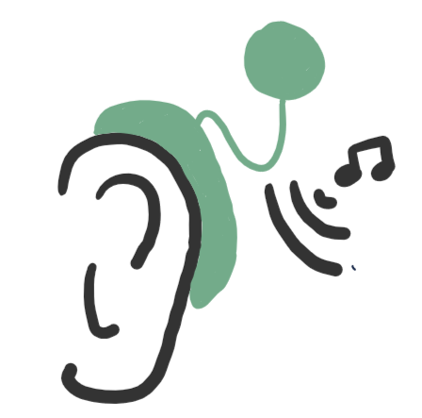 |  | My Hearing Device(s)  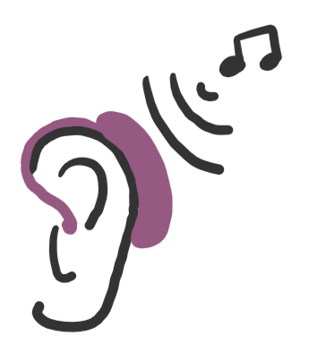 |  | Other:
Allergies:
Medications:
Hearing Device Use?  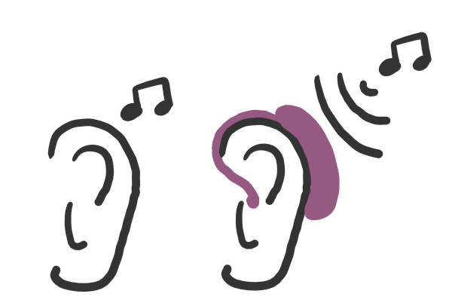  Circle: | 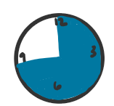  Often |  |  | 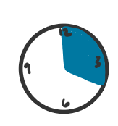  Sometimes |  | 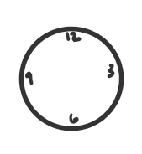  Never
Why I am here today: | I need a well check-up |  | I feel sick  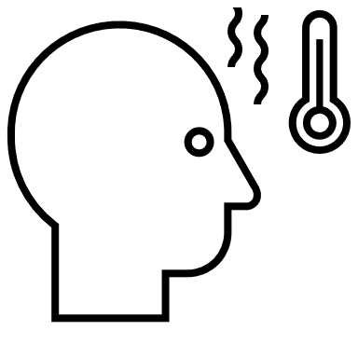 |  | I am hurt |  | Other:
The place(s) where I feel sick or where it hurts is/are:
(Caretakers please add information here too)
This is how much it hurts:
