Hands & Voices
Social Media Strategy 2023
___________________________________________________________________
1. The main purpose of H&V Social Media is to inform and inspire families of children who are deaf and hard of hearing. The secondary purpose is to build connections with other entities that provide services to our families through a social media network.
H&V uses social media for reaching a broad audience of families, leaders, deaf individuals and other organizations. Social media is used for example:
- To increase online brand awareness
- To Improve community engagement
- To increase referral traffic to your website
- To widely distribute H&V products & resources
- To convert followers into donors
______________________________________________________________________________
2. The target Social Media audience for Hands & Voices includes parents, chapter leaders, and outside organizations.
H&V seeks to connect with its primary audience as well as building a community of new and current donors and supporters, volunteers, and corporate sponsors.
As of February 1, 2023, Hands & Voices has an active presence on:
- Facebook Page: 14,663 followers
- Facebook OUR Children Page: 361 followers
- Facebook Groups: 5708 total members
  - Military - 425
  - Deaf Plus - 1204
  - Unilateral - 1515
  - DHH Guides - 77
  - L2L current - 15
  - L2L graduates - 36
  - Chapter Leaders - 125
  - Regional Coordinators – 11
  - Regions 1/2/3 – 20
  - Region 4 – 32
  - Region 5 – 18
  - Region 6 – 11
  - Regions 7/8 – 24
  - Regions 9/10 - 36
  - GBYS - 42
  - ASTra - 56
  - Fostering Joy - 1628
  - Manos Y Voces - 350
  - OUR Children - 83
- Instagram: 2,217 followers
- LinkedIn: 319 followers
- Twitter: 4,927 followers
- YouTube: 242 subscribers
- TikTok: 0 followers
Total followers/members: 28,437

______________________________________________________________________________

3. Develop content topics to post and discuss on social media.
- The importance of parent choice in making decisions for our children who are deaf or hard of hearing.
- The importance of deaf leaders in our journeys.
- You are not alone.
- Parents are leaders.
- D/HH kids can do anything.
- H&V is committed to its DEIA plan and inclusive of a wide range of life experiences.
- There is JOY in parenting a D/HH child.
______________________________________________________________________________

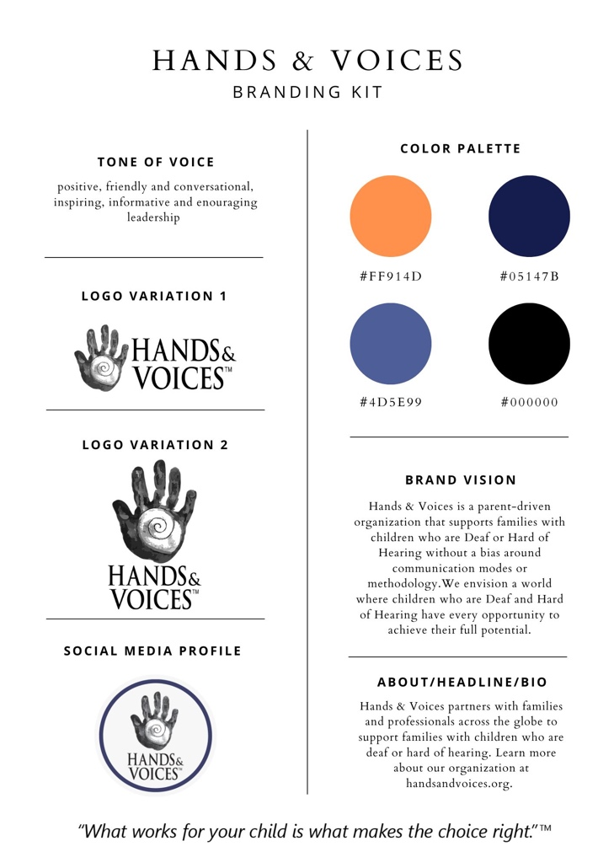
4. Defining the H&V brand.
______________________________________________________________________________
5. DEIA in Social Media
H&V recognizes the importance of Diversity, Equity, Inclusion & Accessibility in all social media postings. Efforts will be made to represent diverse groups of people including racial identity, modes of communication and more. The term “accessibility” includes the use of captions, ASL, Cued Language, etc. where necessary as well as accommodations for DeafBlind individuals including alt text and image descriptions when possible.
______________________________________________________________________________
6. Social Media Budget
Explore usefulness and cost effectiveness of a scheduling & analytics tool such as Hootsuite or Buffer to maximize time. Research organic reach algorithms, analyze H&V data, and define a reasonable social media advertising plan.
______________________________________________________________________________
7. Hands & Voices content marketing plan.
Content marketing with visual appeal and well written verbiage and tone of voice will maximize H&V’s organic (and paid reach) on social media platforms. The following is the content marking plan for 2023 (This does not include resources and research opportunities we are asked to share from other organizations):
- Publish one blog post monthly to website and social media
- Curate one relevant blog or news article monthly from a partner organization
- Write one stat monthly
- Collect one quote monthly
- Compile two individual photos or sets of photos twice a month
- Design two call-to-action social media promo graphics per month
- Create two videos per month (1 DHH adult video/1 not just a mom video)
- Create a Social Media H&V Spotlight monthly
- Create Tuesday Tip posts weekly
- Create two DEIA posts per month
- Create one Spanish-related post per month
- Share existing H&V resource once per week
- Create new H&V product campaigns as needed
- Create Fostering Joy post 1-2 times per month
- Create fundraising campaign for Giving Tuesday (November 2023)
- Create campaign to promote Leadership Conference (September 2023)
- Begin to build TikTok library with goal to post weekly videos in 2023
______________________________________________________________________________

8. Track and report success.
Key metrics will be reported bi-annually using a Social Media Success spreadsheet.

